**Image Identification through Convolutional neural networking**

1. **Abstract**

Artificial neural network’s have been replacing many conventional image processing. Neural networks architecture is derived from human brain, and it is excelling in recognizing the patterns. Traditional Image processing can be replaced by neural networks as their accuracy is better than before. Convolution Neural Network is the best algorithm in Automated Image processing. CNN is majorly used in image recognition, object detection and segmentation. In neural networks increases rapidly as the number of layers increases but it can be solved using convolutional neural network (CNN). It is a feed forward model and it helps in reducing number of layers without reducing the quality of the image.

1. **Introduction**

Image identification is identifying images and dividing them into several classes. The classical approach is digital image processing through histogram equalization followed by Thresholding and opening to remove stray pixels, to measure roundness form skeleton or convex hull. Using the threshold image and original image to segment and identify the object. Identification techniques based on matching represent each class by a prototype pattern vector. An unknown pattern is assigned to the class to which it is closest in terms of a predefined vector. The simplest approach is the minimum distance classifier. The accuracy of this above image processing is low compared to neural networks. Moreover Nowadays, mobile devices are equipped with high-resolution cameras, which results in requirement for high-quality mobile image signal processing. One such method to reduce time, memory and increase accuracy is Convolution Neural networks for image processing.

A convolutional neural network (CNN) is a class of artificial neural network mostly used in image processing. Many large companies are using CNN in object identification. It is used in detection of fraud, identifying the targets in defense, detection of tumors in medical field. A convolutional neural network consists of an input layer, hidden layer and an output layer. CNNs use a mathematical operation convolution in at least one of their layers in place of general matrix multiplication.

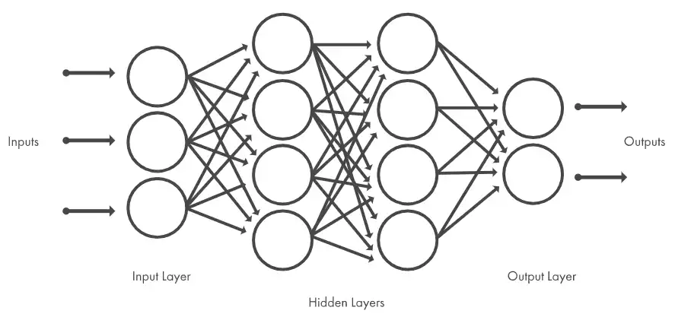

1. **Three layers of CNN:**
   1. **Convolutional layer:**

In this layer a small data of the input is connected to the next layer (Hidden layer). Whereas in general neural networks all the input data is connected to the hidden layer.

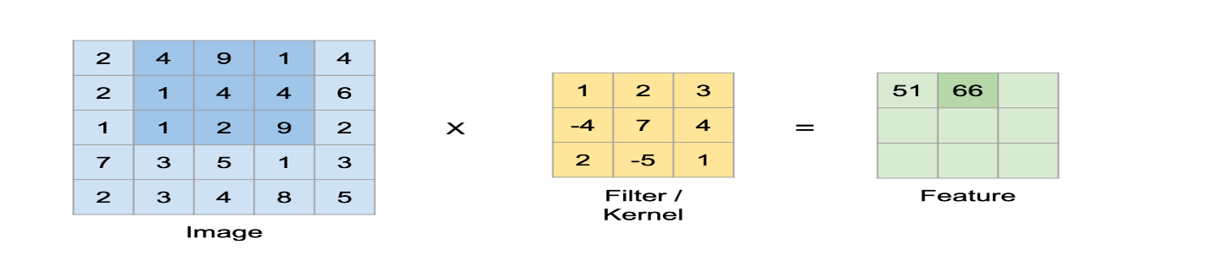

* 1. **Pooling layer:**

It has multiple activation and pooling layers inside the hidden layer. It is used to reduce the dimensionality of the classification. Dimensionality is reduced using sliding window which is less than the size of input data. A convolution is performed using convolution filter and bias is added to the convolution of each filter before passing it through the activation function. It also lowers the computational burden and number of connections between convolutional layers. The following diagram uses maximum pooling.

* 1. **Fully Connected Layer:**

It is next layer connected to hidden layer and is the output derived from the final pooling layer.

1. **Activation Function:**

The performance of Convolutional Neural Networks hugely depends on the activation function. The Re Lu activation function is the most efficient activation function because of its fastness and simple differentiability. It is better than tanh and sigmoid activation function.

1. **MNIST Datasheet:**

It is Modified National Institute of Standards and Technology database. It is collection of handwritten digits. It has test set of 10000 examples and a training set of 60000 examples. Each image is of 28/28 pixels. It is used in image classification and clustering.

1. **Step by Step procedure:**
2. Import all the libraries
3. Set the seed for reuse and import MNIST data
4. Convert the data into float values
5. Normalize the data
6. Import the image
7. Reshape the data as each image of 28/28 pixels, so output of 10 layers and hidden layer neurons of 784.
8. Define the model function and run the model.
9. **Accuracy for different activation functions:**

|  |  |
| --- | --- |
| **Activation Function** | **accuracy** |
| Sigmoid | 91.2 |
| Re Lu | 93.58 |
| tanh | 89.23 |

1. **References:**

Pathak AR, Pandey M, Rautaray S. Application of deep learning for object detection. Procedia Comput Sci. 2018;132:1706–17.

Haojia Lin, Lijiang Li, Xiawu Zheng, Fei Chao, Rongrong Ji. 2022. Searching Lightweight Neural Network for Image Signal Processing. In Proceedings of the 30th ACM International Conference on Multimedia (MM ’22), October 10–14, 2022, Lisboa, Portugal. ACM, New York, NY, USA, 9 pages. https://doi.org/10.1145/3503161.3548288Processing

<https://medium.datadriveninvestor.com/why-are-convolutional-neural-networks-good-for-image-classification-146ec6e865e8>

<https://dl-acm-org.portal.lib.fit.edu/doi/pdf/10.1145/3503161.3548288>

<https://www.altexsoft.com/blog/image-recognition-neural-networks-use-cases/#:~:text=Image%20recognition%20is%20one%20of,%2C%20hidden%20layers%2C%20and%20output>.

<https://en.wikipedia.org/wiki/Convolutional_neural_network#Pooling_layers>

<https://datamahadev.com/understanding-image-processing-using-artificial-neural-networks/>

<https://www.analyticsvidhya.com/blog/2021/06/image-processing-using-cnn-a-beginners-guide/>